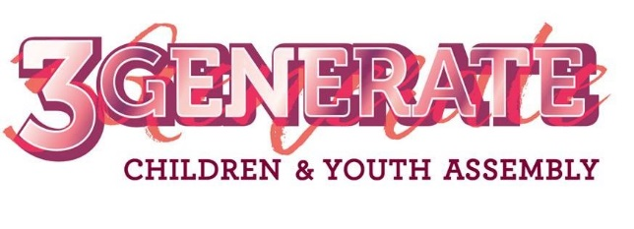
MANIFESTO 2018
SUPPORTING RESOURCES
“We want a church community that is relevant.”
EXPLORING CHILDREN’S AND YOUNG PEOPLE’S VIEWS ON WORSHIP

Below are a variety of activities that will help to begin a conversation with children and young people about different aspects of worship. This may prompt you as a leader to reflect upon whether the worship in your group/at your church is the most relevant and helpful for the children and young people.

WHEN DO YOU WORSHIP GOD?

Preparation: Draw a very large clock on a large piece of paper (e.g. flipchart/ wallpaper).

Activity: Make lots of coloured pens available and ask the children/young people to indicate, around the clock, the time(s) they like to worship God. They could also comment/draw to indicate whether this would be worship in a large or small group, or alone.
The conversation may develop as to what ways they like to worship at different times (e.g. quiet and reflective in the morning).

The aim of this activity is to discover, from the young people, when they would like to worship. This may then help you to think about whether the times for worship at your church are meeting people’s needs.

HOW WOULD YOU LIKE TO WORSHIP GOD?

Preparation: Print out (or draw) a sheet with a ladder on it, one for each small group. There is a sample worksheet on page 3 of this document, which you may wish to use/adapt.

Activity: Ask the group to think of as many different ways of worshipping as they can. Collate a list so that everyone can see. You may want to add some of your own if the young people haven’t mentioned them. Here are some suggestions:
- singing quiet songs
- singing loud songs
- praying alone
- praying as a group
- doing prayer activities
- dancing
- being quiet
- with a big band
- with a choir
- listening to music
- sitting quietly
- hearing the Bible
- reading the Bible
- drama
- watching DVD clips
- making something
- walking.

Ask the children/young people to write onto the rungs of the ladder the different ways of worshipping according to their personal preference. On the top rungs of the ladder they would write the ways of worshipping that they most prefer, and towards the bottom of the ladder they would write their least preferred ways to worship.

MINI MOMENTS WITH GOD

This activity is about finding out how children and young people may like to connect with and worship God in short activities/reflections throughout the day/week. Simply print out enough copies of the worksheet on page 4 of this document for each member of your group, supply them with pencils or crayons, and help them to work through it.

Look at the list. Put your favourite way to worship on the top rung and then work your way down the ladder, adding your next favourite form of worship each time, until you get to the bottom.

Types of worship you
most enjoy.

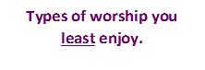

MINI MOMENTS WITH GOD

Sometimes it can be helpful to just take some ‘Mini Moments’ with God, throughout a day or week. These could be areas or activities where you pause and just ‘take a moment’ with God. It could be done on your own or with others, could be active or reflective, online or in a particular place, such as church.

Have you any ideas what these ‘Mini Moments’ could look like? What would help you to engage and connect with God throughout the day? Could you write or draw one in each box?

