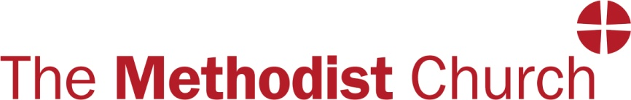

CREATING SAFER SPACE

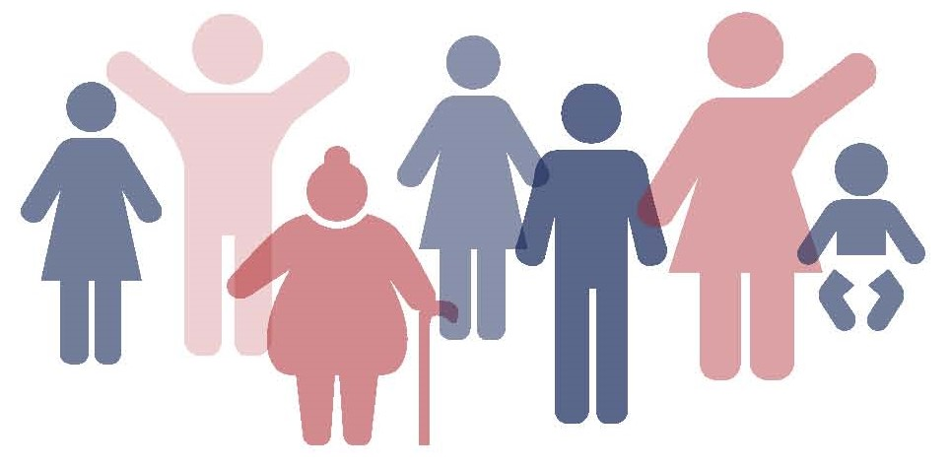

Safeguarding Children, Young People
and Vulnerable Adults

Name
Circuit
District

has completed the
Advanced Module (Online) 2021
Safeguarding Training

Gathered session attended on: Date

The Creating Safer Space Advanced Module aims to:
- consolidate and develop your previous safeguarding learning
- explore what this means in your designated role of responsibility within the Church
- further equip you with skills and resources to be confident in promoting good practice in the Church and community
- extend your understanding of responding well to different groups within the Church community.

Signed: Date:

Name: Role:

