|  |  |
| --- | --- |
|  |  |

Creating Safer Space

Foundation Module 2020 Edition

Zoom - Where to find the buttons on different devices

Desktop or Laptop

iPad

iPhone

Android Tablet

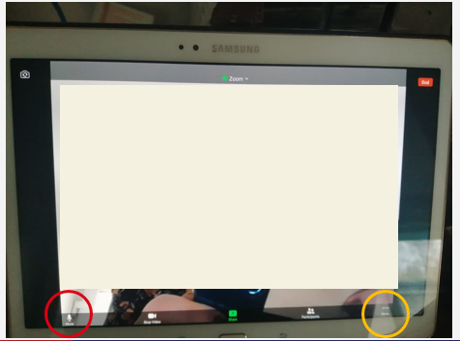 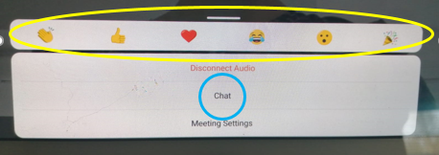

Android Phone

 