The Welcome Audit of your church

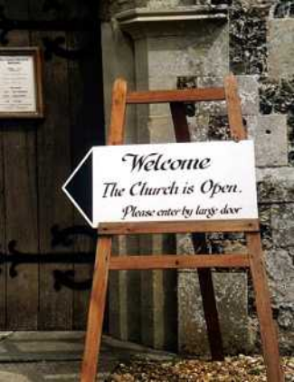
“I believe in God the Welcomer”

“Christian Welcome is not just about being nice to visitors, it is about incorporating new people into the Body of Christ”

Do you agree with this statement? Write your own statement of what you think welcome means. How a newcomer and visitor would feel. How would you like them to have gone away from the church different from the moment they came?

Even though many people come to churches – how are they drawn into more than just a historical monument but into a living Christian community?

Becoming a stranger
The only way to know how a stranger feels is to become one
Try visiting a betting shop,
First impressions leave lasting impressions

A Welcoming Church Exterior

Finding the church
- Signposts
- Church trails
- Brown Signs

Action to take!

Approaching the Church
- Parking
- First impressions
- Church Notice Board
- How attractive and welcoming is it?
- Beware negative signs – e.g. No parking here, No entry
- Are your service times made simple + outcomes? (e.g. BCP and CW are “in-house” and mean nothing)
- Are the contact details displayed, name, address, phone number (academic qualifications not necessary)?
- What about “outcomes” of the experience?
- Is there information for disabled people?
Action to take!

Outside Area
- Often more important than the church for people
- Are paths neat and in good order?
- How neat are the building surroundings? Do they say “ We care” or “We neglect”?

Action to take!

A Welcoming Church Interior

What is the building saying about itself?
- What are the impressions created by architecture furnishings and fittings, light, smell etc?
- A museum?
Mission Statement of a pub in Finedon
“Your next visit is our success”

- A holy place?
- A homely place?
- A forsaken place?

What is the building saying about its life and family?
- Do they care for the building?
- Is the feudal system alive and well?
- Mission Statements and other sentiments
- Magazine available, weekly newsletters, good news stories
- Displays of Sunday School material
- Material for children (as opposed to material about children to make adults go “ahhhhh”)
- Pictures of people - photos of minister/stewards, etc
- Do we really need to know how much it is to bury ashes?
- Out of date notices and “In-house” notices?
- Is there a place to pray, candles lit, lights on, music playing, flowers?

Action to take!

What does our building say about God?
- Is He central or peripheral?
- Is He given a chance to engage with visitors?
- Is it made easy for those who come in and pray? How and where?
- Is there any devotional literature, suitable for the visitor?
- What “atmosphere” is or could be created?

Action to take!

What does our building say about money?
Is it mentioned at every turn?
Does the place look as if money is in short supply or unimportant?

Action to take!

What does our building say about Disability, Comfort, Ambience, and Safety?

A Welcoming Church Member
“consider others better than yourselves” Philippians 2:3

Before the service
- As this is a ministry, why not gather to pray a prayer together
- Whose job is it to welcome people to the church? Are they the best people?
- Do members think of themselves as “ministers of welcome”?
- When is their job over? When the service begins or when the last person leaves?
- What about some people welcoming, whilst other worry about books?
- Do we know where to direct people – especially children and disabled
- What about loos? – clearly marked – on the service paper?
- Where do welcomers stand? Inside or out?
- Good questions to ask: “have you been to Wesley often before?” is better than “are you new”
- Introduce yourself to people
- What happens to late comers? How long are you hanging around at the back? Do you need a piece of felt on the latch or the door?

During the service
- Introduction to the service – why not just give a warm welcome, rather than highlight visitors (after all we are all visitors!)
- Welcomers should be willing to sit with others not just their friends
- To introduce and gently guide through the service if people are struggling

After the service
- How are they welcomed before and afterwards?
- How are we sensitive to different people’s needs?
- How do we find out about people and follow them up?
- Do we have information on the activities of the church as well as its history?
- Invite them for coffee, which means escorting them over, getting them coffee and chatting to them and introducing them to others who may have similar interests
After Sunday
- What about a follow up visit? How can this be organised? A small group of people who call round within about 10 days.
- In an average church, there may be up to 10% of people who have either never come, not come for ages, or are passing through.
- Do you have a welcome pack with a flavour of the life of the community?

Action to take!

How

